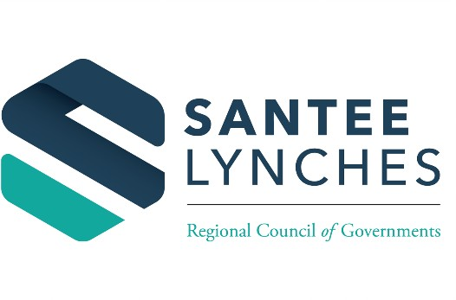

Encl. 2

**Board of Directors Hybrid**

**Central Carolina Technical College 506 North Guignard Dr.**

**Building M400, Rm M401 Sumter, SC 29150**

**Monday June 5, 2023**

**6:00 PM**

**Members Present**

**MINUTES**

**Clarendon County:** Kevin Johnson, Shirley Keels, Julia Nelson, Dwight Stewart **(Zoom)**.

**Kershaw County:** Alfred Mae Drakeford (**Zoom**), Penry Gustafson **(Zoom)**, Jeffery Graham **(Zoom)**, Brad Hanley, John Lee, Kenneth McCaskill **(Zoom)**, Sammie Tucker

**Lee County:** Travis Windham

**Sumter County:** James Blassingame, Jim McCain, Vivian McGhaney **(Zoom)**, Roland Robinson, Gifford Shaw, David Weeks, Chuck Wilson, David Merchant, Bernadetta Robinson **(Zoom)**

# Members Absent

**Lee County**: Will Wheeler

**Sumter County:** David Weeks, Earl Wilson, Herbert McClary

**Guest:** Conn D Munn, Wayne Hancock, Cynthia Biggar **(Zoom)**

1. **Welcome and Call to order:** Chairman Julia Nelson called the meeting to order at 6:11PM.
2. **Invocation:** Ms. Vivian McGhaney provided the invocation.
3. **Pledge of Allegiance:** The Pledge was led by all.
4. **Quorum Determination:** The Board Clerk, Linda Jackson, informed Chairman Nelson we had reached a quorum with 21 board members present.
5. **Agenda Adoption:** Chairman Nelson called for a motion to adopt the agenda. Mr. Sammie Tucker made the motion, and it was seconded by Mr. Chuck Wilson.
6. **Approval of Previous Minutes:** Chairman Nelson called for a motion on the ratification of the December 6, 2021, minutes for adjustment made by Mrs. Vivian McGhaney. Mrs. McGhaney made the motion, and it was seconded by Mr. Chuck Wilson. All were in favor and the motion passed unanimously.

Chairman Nelson called for a motion to approve the February 7, 2022, minutes. Mr. Sammie Tucker made the motion, and it was seconded by Mr. McCain. All were in favor and the motion passed unanimously.

# Public Presentation: None

1. **Staff Reports:** Ms. Rachel Katorkas, Finance Chief, reported to the Board that the financial report that was distributed ran through the end of February. Mrs. Katorkas stated that the COG was 67% of the way thru the fiscal year. She explained that overall, we have brought in 39% of budgeted revenue and expended 53% of budgeted expenses. Part of what is driving that differential is the costs related to the settlement with the former executive director. Other than the settlement line item, advertising and miscellaneous (under expenses) are over-budget due to some grant-related spending, and adjustments for those are included in the proposed budget amendment. Mrs. Katorkas reported that page 3 showed a summary of revenue and expenses by fund. She explained that once again, under local funds, costs are higher than originally budgeted due to the settlement costs. She informed the board that there was more information on the fund balance for the COG at the bottom of page three (3). The fund balance consists mostly of cash.

All other staff reports were enclosures for information only.

# Committee Report:

* 1. **Executive Committee**
     1. **Grievance Policy-Final:** Chairman Nelson presented on behalf of the Executive Committee as a motion and second to approve the grievance policy. All were in favor and the motion passed unanimously.
     2. **Audit/Finance Committee:** Mrs. Alfred Mae Drakeford requested auditor Ms. LeAnn Bagasala from Mauldin & Jenkins to present to the board the 2020-2021 Audit. Ms. Bagasala reported the audit is very close to being completed, statements have been drafted and they are going through the review process which includes a second partner review. They plan to issue the audit within two weeks. From a financial statement perspective, a draft of the financial statements has been prepared and management has prepared their required elements on the statements. A couple of items to note:
        + Total Assets are up $168,140 (net change) from the previous year (Total Assets thru 6/30/21 - $4,289,363)
        + Total Liabilities are up also by $417,832 (Total Liabilities thru 6/30/21 -

$5,673,518)

* + - * Total Net Position is ($1,015,682) – which is a $27,625 net change.
      * Total Revenues - $7,114,565 (a $355,716 net change)
      * Total Expenses - $7,086,940 (a $358,024 net change)
      * Net Position at the End of the Year – ($1,015,682)

Ms. Bagasala pointed out two things from a financial statement perspective:

* + - * There will be a footnote in the financial statements (footnote 14) where several budgetary departments exceed their appropriated amounts which is required supplementary information.
      * They did audit the Workforce Innovation and Opportunity Act Program and there were no current audit findings.

Mrs. Bagasala explained to the Board the Information Technology environment is characterized by rapid change and there has been no shortage of headlines about cybersecurity attacks. While breaches of large organizations have been very high profile and have received a lot of press coverage, organizations of all sizes face the same types of threats and are experiencing similar breaches. Many organizations are still struggling to effectively address cybersecurity issues; however, they are no longer ignoring them. She stated that during the performance of the audit of the financial statements of the Council, they noted that the organization is lacking some elements of a Cybersecurity Framework or Cybersecurity Risk Management Program (CRMP). A functioning CRMP will assist the Council with comprehensively identifying cybersecurity weaknesses, potential threats and risks, and controls used to safeguard information and systems. Ms. Bagasala recommended that the entity investigate and consider implementation of a Cybersecurity Risk Management Program covering cybersecurity risk assessment, software updates/patching cadence, audit security measures, and monitoring and testing of controls in place.

Ms. Bagasala stated that at this time, there is nothing included in the auditor’s discussion and analysis to bring to the Board’s attention. Specifically, there were no audit adjustments or control deficiencies noted that are required to be communicated. She finished her report by stating there are some very important GASB’s coming up that need to be considered that they have discussed with management. Most important is GASB 87 related to leases that will impact the June 30, 2022, fiscal year.

# Regional Development Corporation (RDC) Annual Membership Meeting

* 1. **Approve Previous Meeting Minutes:** Mr. Jeffery Graham, RDC President, called for a motion to approve previous meeting minutes. Mr. Chuck Wilson made the motion to approve the meeting minutes and it was seconded by Mrs. Alfred Mae Drakeford. All were in favor and the motion passed unanimously.
  2. **RDC Financial Report:** Mrs. Rachel Katorkas, Chief of Finance, briefed the Board that overall RDC was about 101% of budgeted revenue and 10% budgeted expenses. The bulk of the budgeted revenue was from amortized revenue which came from the forgiveness of the notes payable to SC Housing. She explained that the bulk of the budgeted expenses came from the loss on the sale of the NIP properties. The lost posted for this fiscal year is just over

$233,000, which came from the sale of 16 properties in Sumter at the time the report was prepared. The RDC still held deeds to 64 properties in Sumter and Camden with the total book value of almost $1.4 million. Mrs. Katorkas explained that since there has not been work done to the property surveys and sight clean up, there are no expenses there yet. She brought to the Board’s attention that the COG will have to return approximately $123,000 in unspent maintenance fees for NIP to SC Housing. Mrs. McGhaney requested justification as to why such a large amount of funds are being sent back. Ms. Katorkas explained that there were not any issues that arose, but that funds were received in advance for maintenance work on the

NIP properties. All of the funds were not needed. She verified due to the maintenance being completed, the unspent funds will be sent back.

* 1. **RDC Audit Report:** Ms. LeAnn Bagasala reported the RDC’s audit is very close to being completed, statements have been drafted and they are going through the review process of partner and second partner. Plans are to issue audit within two weeks. She mentioned that the staff at Mauldin & Jenkins implemented GASB 84 on the current year statement which means there will be a combined statement of fiduciary net position and a statement of changes in fiduciary net position on the financials this year. GASB 84 required these statements for the RDC’s custodial funds (previously agency funds) which are the Pinewood Development and Sumter County projects. They did have to restate net position by $16,256 for the Pinewood Development as part of this implementation.

A couple of items to note:

* Total Assets - $1,794,949
* Total Current Liabilities - $109,480
* Net Liabilities and Net Position - $1,794,949
* Total Revenue - $993,394; Total Expenses - $1,243,905; Change in Net Position: ($250,511)
* Net Position at the End of the year - $1,685,470

Ms. Bagasala pointed out that there was the loss on the sale of capital asset, which was offset by the debt forgiveness. She completed by the report by stating that at this time, there is nothing included in the governance letter to bring to Board’s attentions. Specifically, there were no audit adjustments or control deficiencies noted that are required to be communicated.

* 1. **Proposed FY 2022-2023 Board of Directors Slate:** Mr. Graham called for a motion to approve the Proposed FY 2022-2023 Board of Directors Slate. Mr. Sammie Tucker made the motion and it was seconded by Mr. Jim McCain. All were in favor and the motion passed unanimously.

# Other Business: N/A

* 1. **Adjourn:** Mr. Graham called for a motion to adjourn the RDC Annual Membership Meeting. It was so moved by Mrs. Drakeford.

# Old Business:

* 1. **2020 Census Report-Impact on Board Composition:** Mr. Dennis Cyphers, Government Service Chief, informed to the board that Kershaw County was the only county that had large growth. Kershaw County and the City of Sumter County were the only areas that added seats. He explained that the breakdown of each included in Enclosure 12.
  2. **COG Board Composition Adjustments:** On behalf of the Executive Committee, Chairman Nelson made a motion for the City of Sumter to distribute one (1) seat to Lee County which will give them three (3) seats instead of two (2); Sumter will have thirteen (13), Kershaw nine (9), and Clarendon four (4). Mrs. McGhaney thanked the City of Sumter for giving one seat to Lee County. The motion was seconded by Mrs. Drakeford. All were in favor and the motion passed unanimously.

Chairman Nelson informed the Board that the Executive Committee will now work on the By-laws at its May meeting to incorporate the changes and the amended By-Laws will be presented to the Board at the June meeting.

# New Business:

* 1. **Review FY 2021-2022 Budget Amendment:** Mrs. Drakeford explained to the Board that the Audit/Finance Committee met twice in the month of March to review the proposed budget amendment for FY 2021-2022 and the proposed budget for FY 2022-2023. She mentioned that both proposals have been reviewed thoroughly. The committee is not seeking a vote on the amendments at this time but is providing them to the Board for information/review only. If Board members have any questions, they may contact the Interim Executive Director or Finance Chief. The Audit/Finance Committee will seek adoption at the next meeting in June.

Mr. Gifford Shaw stated that he would like to see administrative costs versus costs for the actual services provided. Mrs. Katorkas explained that the line items in the budget for HOME rental assistance, HHS services, and WIOA services are for services that are provided directly to clients. The other costs in the budget are for overhead and for staff working directly with clients. Mrs. Katorkas stated that she can gather the information requested for the board. Mr. Shaw stated that he believes it would be helpful to see administrative costs versus costs directly related to providing services.

Regarding the budget amendment, Mrs. Katorkas stated that budget amendments are done each year because when we are preparing the original budget, we do not yet have information on the allocation of funds for each of our programs from the State. Adjustments have to be made based on the allocations actually received, as well as for new funding that comes in from grants that are applied for throughout the year, other projects, and technical assistance agreements. Expenses also have to be adjusted based on the changes in the allocations that are received for each program. Some of the additional expenses in the budget amendment compared to the original budget include the settlement costs for the former Executive Director and vehicle purchases, which had previously been brought before the Board. The costs associated with the COG’s Anniversary celebration were removed as we were unable to have any events due to the pandemic. The cost for new accounting software has also been removed but was included in the proposed budget for next year.

The budget for next year is based on where we stand right now with revenue and expenses. Just like this year, we anticipate having to do a budget amendment next year because we don’t yet have final allocations for our major programs.

1. **Next Steps-Executive Director’s Search:** Chairman Nelson informed the Board that the Executive Committee created a search committee with representation from each county. For Sumter County, Mr. James Blassingame and Mr. Jim McCain; for Kershaw County, Mr. Sammie Tucker and Mr. Jeffery Graham; for Lee County, Mr. Will Wheeler, and for Clarendon County, Mr. Dwight Stewart and Chairman Julia Nelson. She mentioned that Ms. Areatha Clark has reached out to the SC Association of Counties and the Municipal Association of SC, and they have agreed to post the Executive Director’s position. The Executive Committee has given the search 30 days and has instructed staff to contact the two (2) entities within 30 days to collect the resumes. Chairman Nelson explained that they are trying to avoid the cost of hiring other entities to complete the search for the COG. The cost was up to $10,000 and the Executive Committee feels more comfortable using the SC Association of Counties, the Municipal Association of SC and other platforms.
2. **Executive Director’s Report:** Interim Executive Director Areatha Clark briefed the Board that it’s time to reactivate the Building Taskforce Committee. The current location, 2525 Corporate Way, is up for sale and therefore, it is time to look for a new home for the COG. She informed the Board of the

current Building Taskforce Committee members: Ms. Alfred Mae Drakeford (Chairman), Mr. Grady Brown, Mr. Kevin Johnson, Mr. Jim McCain, Ms. Julia Nelson, Mr. Dwight Stewart, Mr. Sammie Tucker, Mr. Chuck Wilson, Mr. Earl Wilson, and Mr. Travis Windham. Ms. Clark added that the Board Clerk, Ms. Linda Jackson, will send out a doodle poll to set up the meeting to begin the process.

1. **Chairman Remarks:** Chairman Nelson informed the Board that there has been some discussion regarding the time the Board should meet. She stated that for individuals who are working, 5:00 pm appears to be a strain with being in place for the meeting. She explained that Board Clerk, Ms. Linda Jackson, will send out a doodle poll for members to vote on current times to stay the same, Executive at 5:00 pm and Board at 6:00 pm or have Executive Committee begin at 6:00 pm and the Board at 7:00 pm. She encouraged all Board members to participate in the poll. Chairman Nelson thanked everybody for attending the meeting in person and via zoom.
2. **Adjourn:** Chairman Nelson entertained a motion to adjourn. Mr. Tucker made the motion, and it was seconded by Mr. Roland Robinson. All were in favor and the motion passed unanimously.

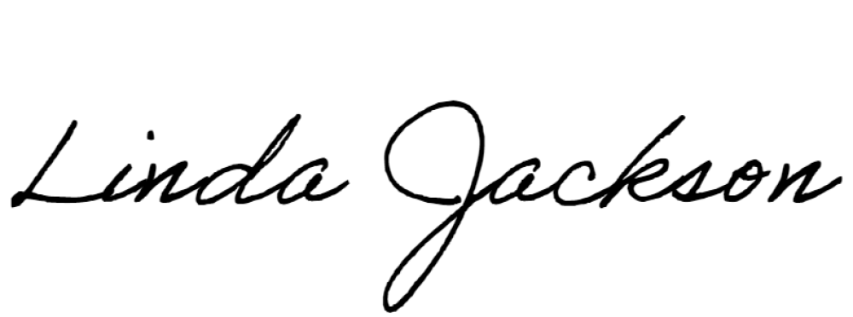Submitted by:

Linda Jackson Board Clerk

Approve by:

Areatha Clark

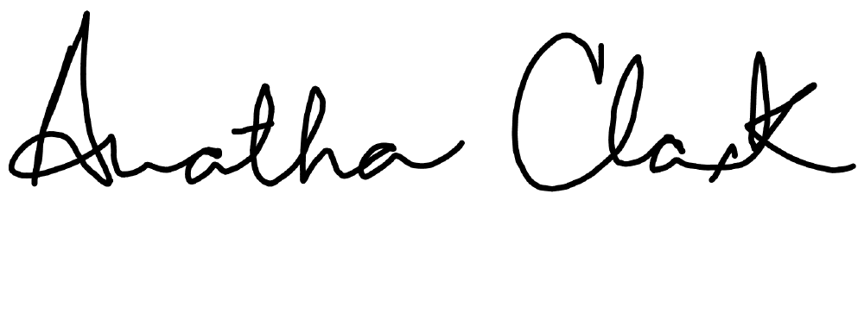Interim Executive Director

*****************************************************

I certify that the public and media notifications of the above-mentioned meeting were given prior to the meeting as follows:

Public Notified: Yes

Manner Notified: Agenda was posted on Bulletin Board at 2525 Corporate Way, March 29, 2022

Media Notified: Yes

Manner Notified: Agenda emailed to local newspapers: The Item and The Chronicle

Date Notified: March 29th and 30th, 2022