**FOR IMMEDIATE RELEASE**

**Media Contact:**  
Sharon Bonney  
Chief Executive Officer  
888.44.COABE  
info@COABE.org

**Clarendon County Adult Education Honored with Multiple National Awards from COABE**

**Manning, SC, March 2025** — Clarendon County Adult Education (CCAE) has been nationally recognized by the Coalition on Adult Basic Education (COABE) with two prestigious awards: the *Excellence in Local Programming Award* and a *Local Enrichment Fund* grant from COABE’s Educate and Elevate Foundation.

CCAE was honored for its exceptional commitment to adult learners, boasting a 95% retention rate in the 2024–2025 school year, a growing regional footprint, and a track record of student success. "Clarendon County Adult Education’s vision to give back to society and help others at every turn is what makes this program truly exceptional," said Sharon Bonney, CEO of COABE. “We are proud to support their continued impact through both recognition and funding.”

The Local Enrichment Fund will support the hiring of three highly qualified part-time instructors to teach GED and high school diploma classes. The new team will also offer career and workplace readiness certifications, crucial for both general and incarcerated adult learners preparing for workforce reentry. A new satellite site in Paxville will expand services across county lines.

“The impact of additional funding and our recent recognitions is tremendous,” said Lara Kolb, Director of CCAE. “We are not only increasing access, but also raising the bar for outcomes—currently, 25% of our graduates are continuing their education, and 50% have joined the workforce.”

The Excellence in Local Programming Award, funded by Essential Education, celebrates innovation and results in the field. "Clarendon County Adult Education is a shining example of how commitment and a focus on student success can transform lives," said Dannielle Doyle, President of Essential Education.

With a recent move to a more accessible location, increasing enrollment, and a string of five statewide awards—including the Adult High School Completer Award for having the highest percentage of high school diploma earners—CCAE is setting the standard for adult education programs nationwide.

**About COABE**  
COABE represents over 82,000 adult educators nationwide and is committed to inspiring educators so adults succeed and communities thrive. Learn more at [www.coabe.org](http://www.coabe.org) or contact awards@coabe.org.

**About the Educate and Elevate Foundation**  
The foundation provides supplemental grants to local programs that demonstrate excellence and need in serving adult learners. Visit [www.educateandelevatefoundation.org](http://www.educateandelevatefoundation.org) for more information.

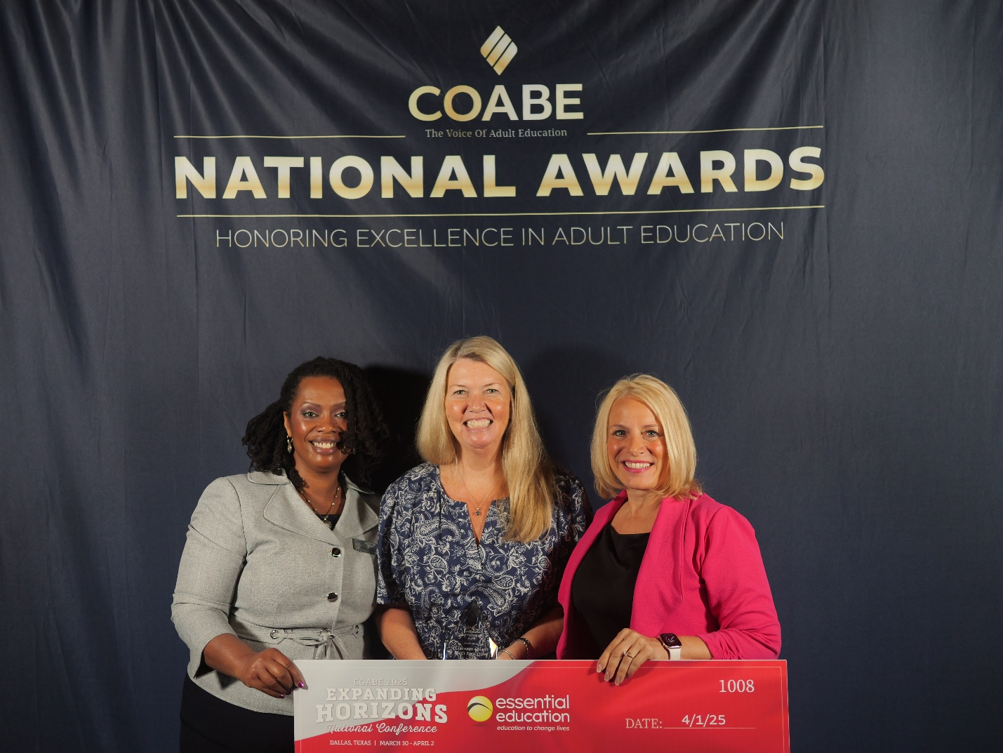

Shaketta Thomas, President of COABE, Lara Kolb, Director of CCAE, Sharon Bonney, CEO COABE

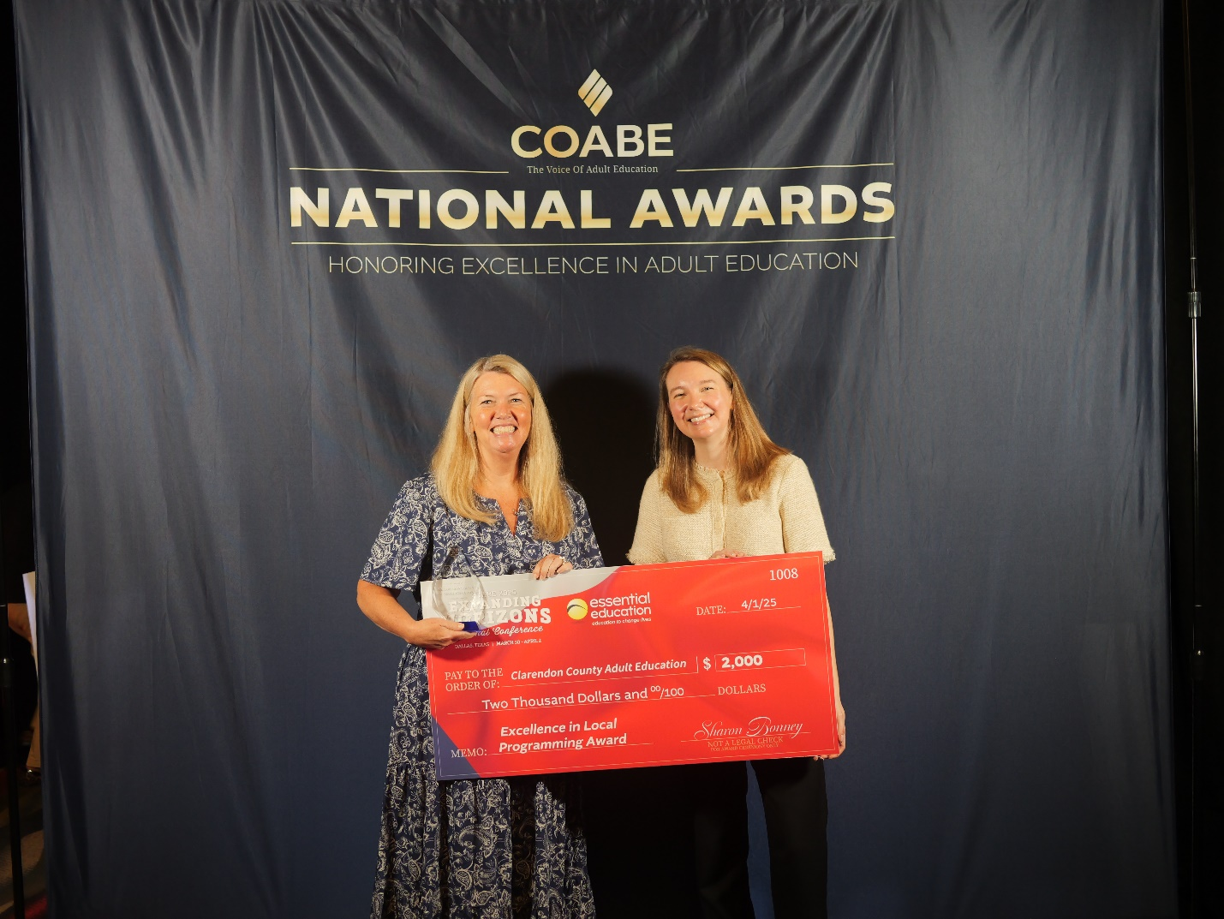

Lara Kolb, Director of CCAE and Dollar General Literacy Award Presenter